Before Coding I actually need to know what kind of game I will develop and the most important: I only have less than 3 days.

Step 1: Getting the idea
Okay, I know that I need to do a tower defense style game, first of all: I need to know exactly what is consider a tower defense and what isn’t.
According to Wikipedia:
The goal is to defend a layer's territories or possessions by obstructing the enemy attackers usually achieved by placing defensive structures on or along their path of attack.
The basic gameplay elements of tower defense are:
- Territories, possessions, domiciles, loved ones (or collectively the "base") that must be defended by the player or players[1]
- waves of multiple incoming "enemies" that must be defended against
- placement of "tower" elements, such as towers, or obstructions along the path of attacking enemies

Geometry wars
So according to that my first idea of creating a geometry war’s style game was denied because the player itself is not consider as a territory and there is no place for towers or something like that. So.
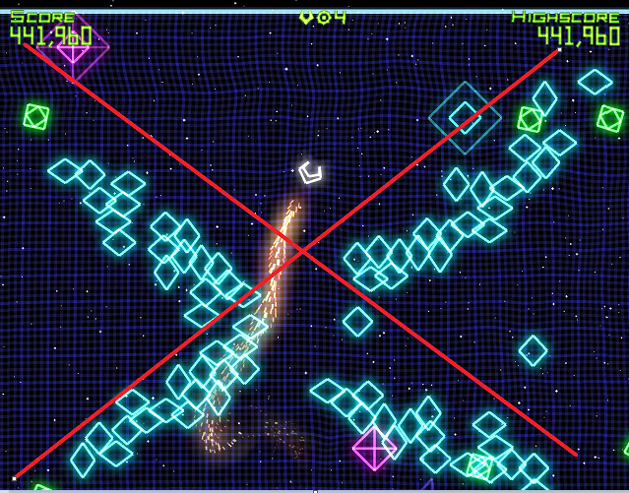
But there are several things that I want to keep into my game such as score, highscore and if I have time a leaderboard.
So next idea:

Bloons td 5
This is the base reference game sent into the email, but even that this represents perfectly the concept of tower defense, is to generic in my opinion and I want to do something experimental, so I going to discard all similar appearance games.
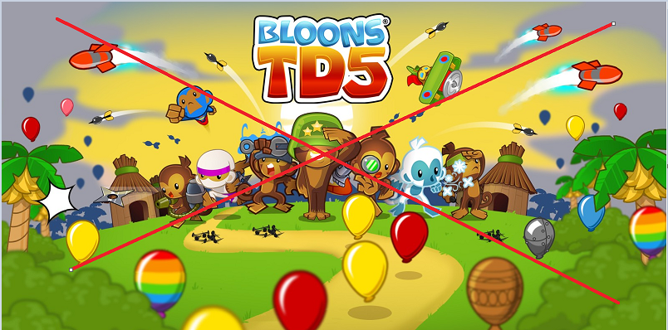
Even though this game gave me an idea: this has several flying resources and I kind of like that, so I will keep with the flying idea.

The final decision
After 3 hours of researching I wont came with something interesting, something fun but simple, because remembering I want to do a flying tower with some leaderbord in it so that will consume time, I was stuck until I remembered a very fun game SPERM WARS. And now I have it!

Sperm wars
This game have all the mechanics that I was looking for, this is kind of 1 vs 1 style game that consist of conquer zones that help you to create soldiers faster and gain power against your enemy, but you can lose territories, so you have to be smart because capturing territories or attacking enemies consume resources, and you need to play very well. So that will be my base.
This also includes the possibility of increase your units power by researching, but I don’t have time to implement that, I need to maintain this very simple. Also I would like to add a multiplayer but maybe in the next time c:






note:
I know the game’s name is very funny.

Summarizing
- Space of flying concept
- Linear attack against structures
- Score
- Max score
- Leaderboard

Step 2: Select the framework
My firs idea was to do all this in Javascript using one of many engines there are, but the problem would be that I need to do all from scratch and do a lot of research because I need to learn the tool first and I have a limited amount of time, so I will opt to do it in Unity and C# even though I need to do a lot of research as well.

